Scrum Summary

for
CitiSense: A Smart Web App for Automated Bilingual Feedback Processing and Data Visualization

Prepared by
Group Name: QuadThink
Lorenzo Emil S. Bernal | 2023-140197 | lsbernal@student.apc.edu.ph
Gabrielle J. Cabangcala | 2023-140039 | gjcabangcala@student.apc.edu.ph
Luis Lorenzo Lazaro | 2023-140004 | ldlazaro2@student.apc.edu.ph
Mark Lyster C. Marabi | 2023-140272 | mcmarabi@student.apc.edu.ph

02/22/2026

Sprint Planning – 01/16/2026
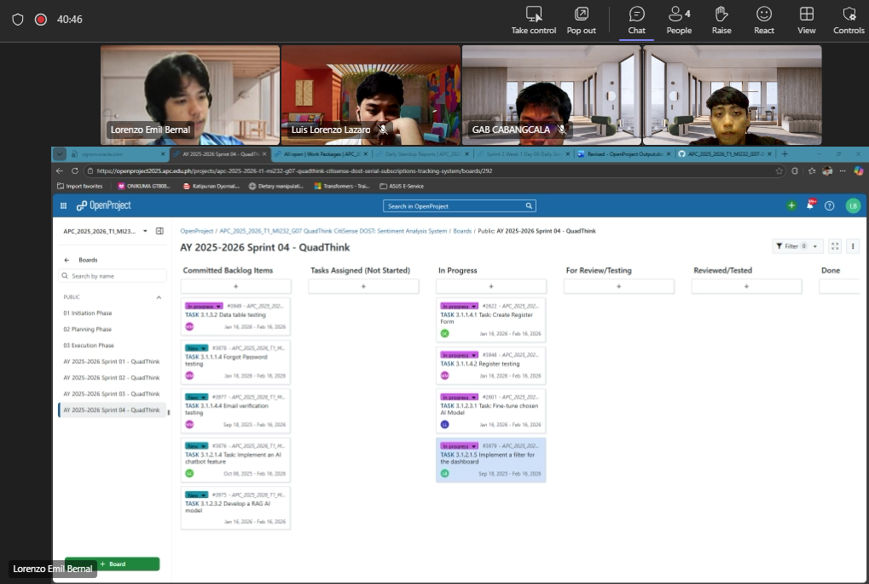

Note: The recording link was deleted. That’s why there is no recording link for the sprint planning

Proof:
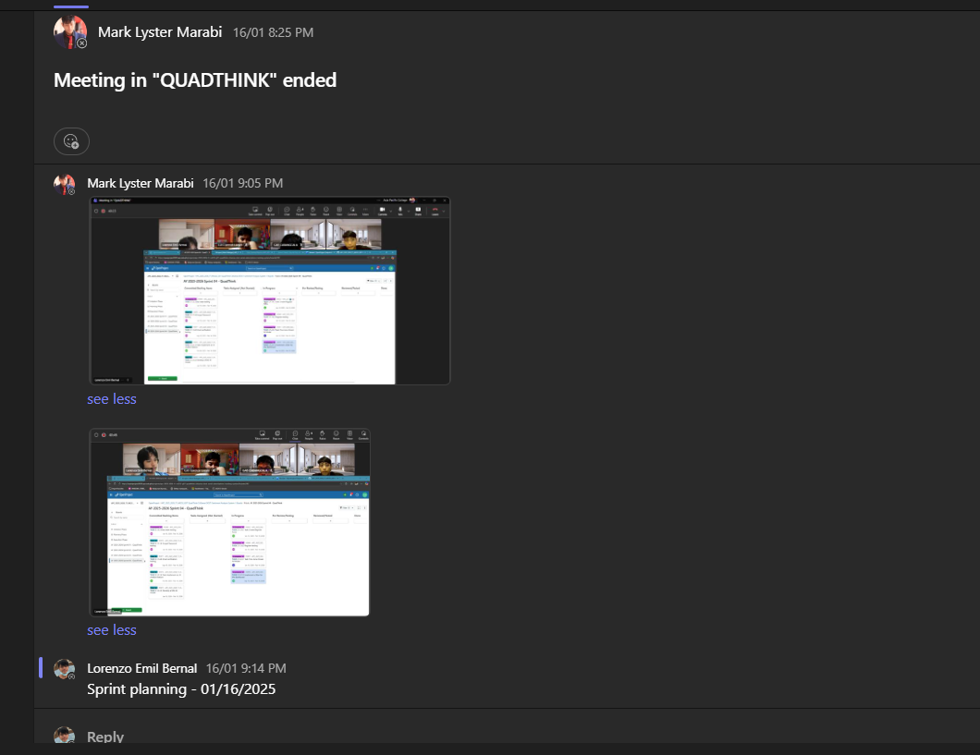

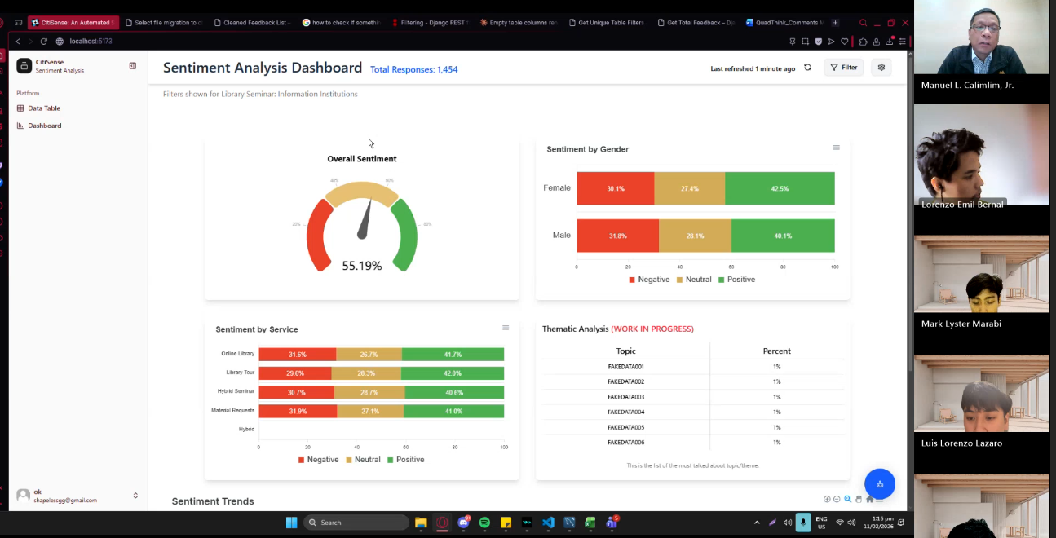
Sprint Review with Sr. Manuel Calimlim – 02/11/2025

Recording with Sr Manuel Calimlim: QUADTHINK weekly meeting with Adviser-20260211_130713-Meeting Recording.mp4

Sprint Review with Ms. Roselle Gardon – 2/12/26
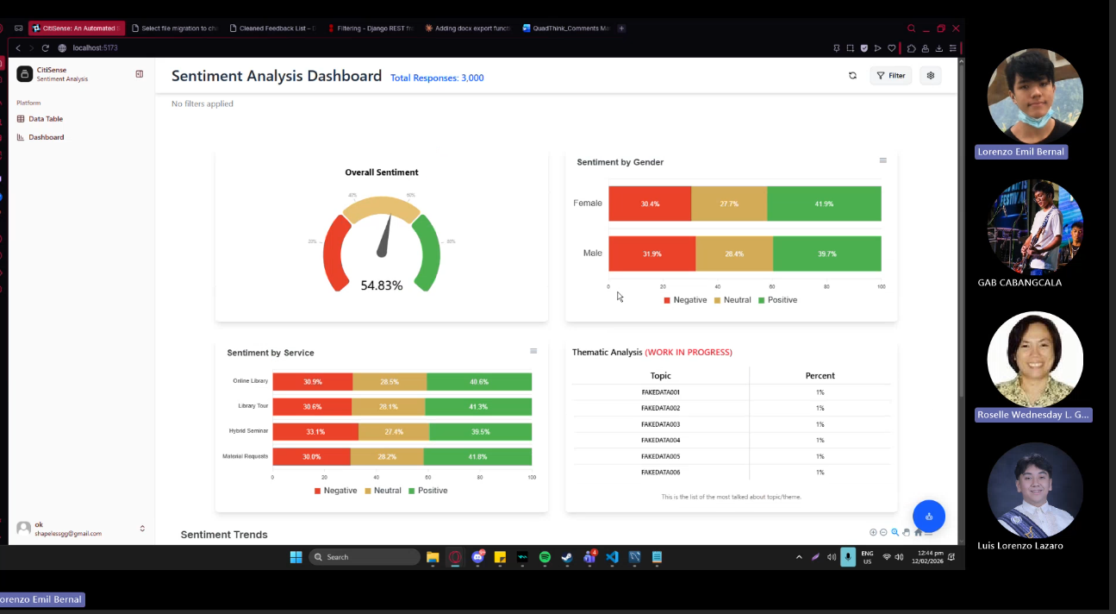

Recording with Ms. Wednesday: QUADThink SCSPROJ Adviser Meeting-20260212_043556UTC-Meeting Recording.mp4

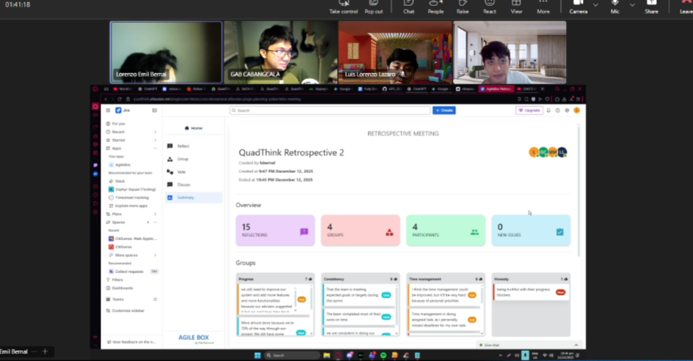
Sprint Retrospective – 12/12/25
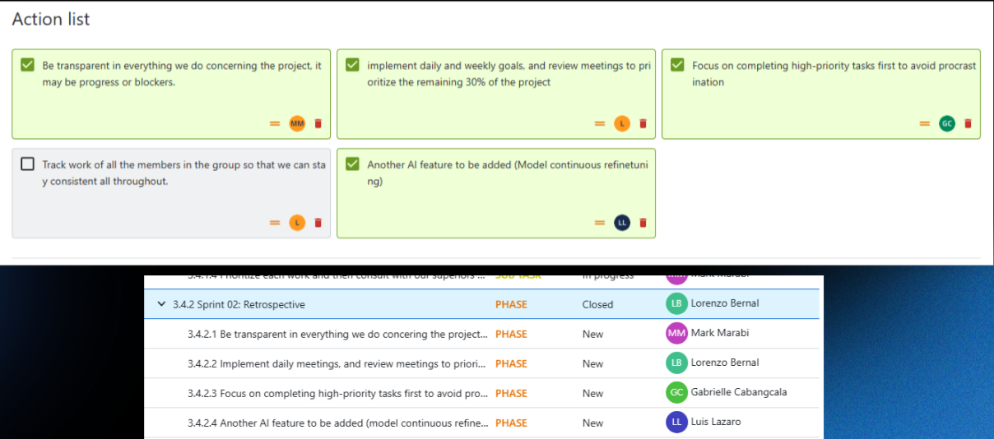

Recording: Meeting in QUADTHINK-20251212_215522-Meeting Recording.mp4

Sprint Retrospective – 02/22/2026

Recording: Meeting in QUADTHINK-20260222_215242-Meeting Recording.mp4

